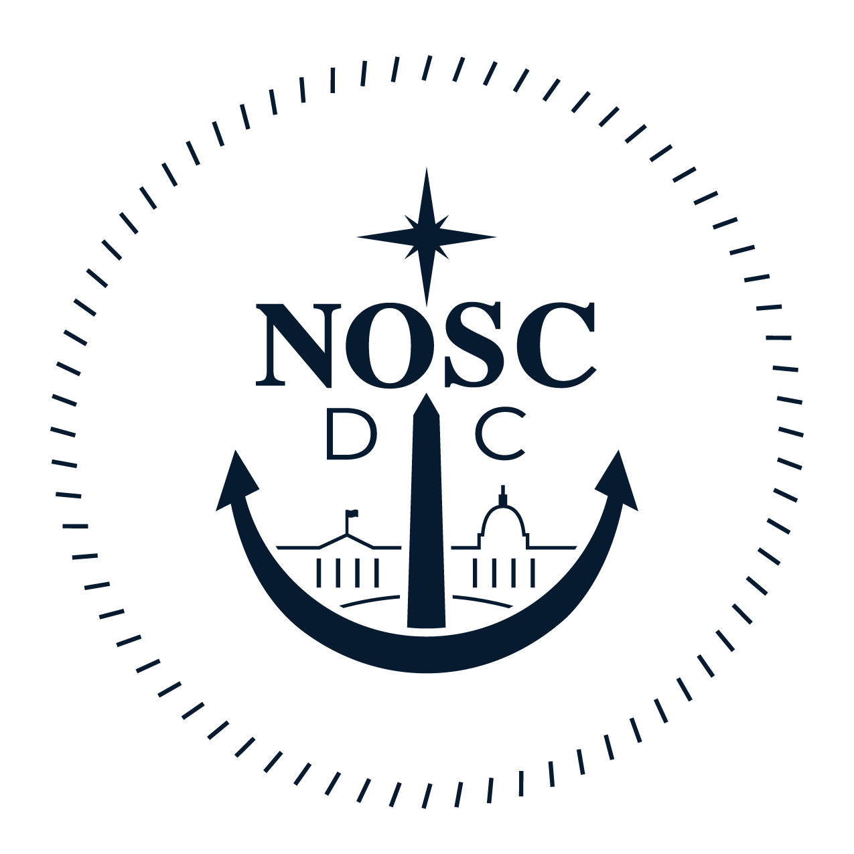 | NAVAL OFFICERS’ SPOUSES’ CLUB OF WASHINGTON, DC  2017 SCHOLARSHIP APPLICATION FORM – HIGH SCHOOL SENIOR  APPLICATIONS MUST BE POSTMARKED BY APRIL 1, 2017

The Naval Officers’ Spouses’ Club of Washington, D.C. will award merit-based scholarships to graduating high school seniors.

ELIGIBILITY:
- The applicant must be a dependent child of an active duty, retired from active duty, or deceased United States Navy (USN) service member.
- The USN service member in question must: (a) currently reside within the Naval District of Washington (NDW), defined as “the District of Columbia; the Maryland counties of Anne Arundel, Calvert, Charles, Frederick, Montgomery, Prince George's, and St. Mary's; the Virginia counties of Loudoun, Fauquier, Fairfax, Prince William, Stafford, King George, Westmoreland, Arlington, and the cities within their outer boundaries;”(b) currently serve in a command situated within NDW; or (c) have, if retired, previously served in a command situated within NDW.
- The applicant must be in his or her senior year of an accredited high school or program and reside within NDW.
- For the 2017-2018 academic year, the applicant must have applied for acceptance as a full-time student at an accredited institution, such as a two- or four- year undergraduate college, a visual or performing arts school, or a vocational/technical school. If awarded a scholarship, the student must use the monies provided during the 2017-2018 academic year. The applicant will be considered no longer eligible if he/she accepts a placement at a service academy, uses the G.I Bill in conjunction with a Yellow Ribbon program or receives any other full scholarship.
- The applicant must be a U.S. citizen and possess a valid military dependent identification card. This identification card must be shown upon request.
AWARDS:
- Scholarships are awarded on the basis of scholastic achievement, school involvement, and community involvement. Financial need is not considered.
- The club treasurer will pay awards directly to the accredited institution that the scholarship recipient will be attending. Awards will only be paid after receipt of attendance verification from the college or university.
- Awards will be applied to tuition and/or fees. Awards will not be used for room, board, books, or personal expenses.
- Awards will be paid in a single installment.

INSTRUCTIONS:
- The entries on this application form must be complete, accurate, and legible. They must be typewritten or printed in black ink.
- Ensure that the information you enter about your sponsor accurately describes his or her current status. For example, if the sponsor is on active duty, the information must describe his/her current affiliation, status, etc. If he/she is retired or deceased, the affiliation, status, etc., must be that which pertained at the time of his/her retirement or death.
- Fill in all information requested. If the answer is “none” or “not applicable”, please make that statement.
- Review the form for completeness and all answers for correctness. Use this year’s current form. Do not send resumes or copies of awards. Provide only the information requested.
- Sign the application form in all appropriate places and ensure that your sponsor does as well. (If your sponsor is unable to sign the application, please state why he/she is unable to sign and who is signing in your sponsor’s place). There are two different forms that must be signed. APPLICANTS WILL BE INELIGIBLE FOR CONSIDERATION IF ANY SIGNATURES ARE MISSING!

Continued on Page 2
**There are seven (7) items required for application consideration**

1. _____ | Completed Application
2. _____ | Essay
3. _____ | Copy of Official High School Transcripts  **Only official high school transcripts will be considered.  Do not open sealed envelopes. ‘Unofficial’ transcripts will not be considered.**
4. _____ | Signed Privacy Statement (signed by applicant and sponsor)
5. _____ | Signed Publicity Statement (signed by applicant and sponsor)
6. _____ | High School Information Sheet
7. _____ | If Applicable: Official College Transcripts for Dual Enrollment

For any questions, please contact NOSC Scholarship Chairman, Mary K Page, at scholarship@noscdc.com .

Mail to: Naval Officers' Spouses' Club of Washington DC Scholarship Committee
6403 Chatham Park Drive
Brandywine, MD 20613
PART I: APPLICANT INFORMATION

1. Applicant’s Name: _______________________________________________________________
2. Address: ________________________________________________Suite/Apt #:_____________
City: ______________________________________ State: _________ Zip: ______________
3. E-mail Address: _________________________________________________________________
4. Home Phone Number: (_____) ___________Cell Phone Number: (_____)___________________
5. Gender (Circle): F M
6. Name of current High School: ______________________________________________________
Address: ____________________________________________________________________
City: ___________________________ State: ______________ Zip: ____________________
7. Total number of high schools attended during grades 9 - 12: __ High School Graduation Date: ___
8. Intended field of study: ____________________________________________________________

PART II: SPONSOR’S INFORMATION (Parent, or legal guardian through whose military service qualification is claimed)

1. Name of sponsor: _______________________________________________________________
2. Relationship of sponsor to applicant: _____________________________________________
3. Sponsor’s home Address (if different from applicant’s): ___________________ Suite/Apt #:______
City: _______________________________ State: ______________ Zip: ________________
**CHECK THE CORRECT BOX**
[___] My Sponsor is Active Duty. My Sponsor’s Current Rate/Rank is: _______________________
Name of Sponsor’s Current Duty Station: __________________________________
Address of Current Duty Station: ________________________________________
[___] My Sponsor is Retired from Active Duty. My Sponsor’s Rate/Rank was____________________
Name of Sponsor’s Duty Station in NDW: __________________________________
Address of Duty Station in NDW: _________________________________________
Years Stationed There_________________________________________________
Date of retirement: ________________________________________
[__] My Sponsor is Deceased. My Sponsor’s Rate/Rank was:________________________________
Name of Sponsor’s Duty Station in NDW: __________________________________
Address of Duty Station in NDW: _________________________________________

PART III: HONORS AND EXTRACURRICULAR ACTIVITIES
Honors: Briefly list any academic distinctions or honors you have received since the 9th grade including school, church, and community. (e.g. National Merit, Cum Laude Society).

Grade Level Academic Distinction
9 10 11 12
___ ___ ___ ___ ___________________________________________

___ ___ ___ ___ ___________________________________________

___ ___ ___ ___ ___________________________________________

___ ___ ___ ___ ___________________________________________

___ ___ ___ ___ ___________________________________________

___ ___ ___ ___ ___________________________________________

Extracurricular: Please describe your extra-curricular activities (band, performing arts, athletics, church, civic). Include specific events and/or major accomplishment such as musical instrument played, varsity letters earned, etc.

Grade Level Activity-honors won, letters earned, positions held
9 10 11 12
___ ___ ___ ___ ___________________________________________

___ ___ ___ ___ ___________________________________________

___ ___ ___ ___ ___________________________________________

___ ___ ___ ___ ___________________________________________

___ ___ ___ ___ __________________________________________

Total Hours spent on extracurricular activities during High School________________

PART IV: WORK/VOLUNTEER EXPERIENCE Include both paid and volunteer experience. Circle whether your position is work (W) related or volunteer (V) related.
Your duty Employer/Organization Dates Total Hours
W V ________________ _____________________ _____________ _____________
W V ________________ _____________________ _____________ _____________
W V ________________ _____________________ _____________ _____________
W V ________________ _____________________ _____________ _____________
W V ________________ _____________________ _____________ _____________
Total Volunteer Hours completed during High School_______________________
Total Work Hours completed during High School___________________________
PART V: EDUCATIONAL PLANS
Accredited college(s) to which you have applied City State Accepted

_____________________________________________ ______________ _____ __________

_____________________________________________ ______________ _____ __________

_____________________________________________ ______________ _____ __________

_____________________________________________ ______________ _____ __________

_____________________________________________ ______________ _____ __________

_____________________________________________ ______________ _____ __________

PART VI: ESSAY

We would like to know more about you, specifically what makes you uniquely qualified for this
scholarship.

- How would you describe yourself, your weaknesses, your strengths, and your challenges?
- How have your experiences as a military dependent shaped your life?

On a separate piece of paper, please write an essay that is no more than 600 words that addresses all of the above questions.

PART VII: LETTER OF RECOMMENDATION
Include a one-page letter of recommendation from one of your high school teachers, counselors, or principals who is not a relative. Letters of recommendations should include examples of academic/work and personal achievements which serve to illustrate both your character and your fitness to receive the NOSC scholarship

NAVAL OFFICERS’ SPOUSES’ CLUB (NOSC) OF WASHINGTON, D.C.
2017 SCHOLARSHIP APPLICATION
PRIVACY STATEMENT

The purpose of the information is to apply for educational financial assistance. Information provided will be used to assess scholastic achievement. Completion of the form is mandatory. Failure to provide required information may result in disqualification from participation in the scholarship program. All application information and documentation must be postmarked no later than April 1, 2017. Incomplete application packets or applications postmarked after the deadline are ineligible for consideration.
We certify that this application and all supporting documents, to the best of our knowledge, are complete and accurate and that the applicant possesses a valid military dependent identification card. Upon request, we will make that identification card available for review by the NOSC of Washington, D.C. We further understand that all monies awarded will be used for tuition and fees only. We understand that if the recipient accepts admission into a service academy or receives a full scholarship, he/she is no longer eligible for a NOSC Scholarship.
We further understand that the information in this application is exclusively for the use of the NOSC of Washington D.C. Scholarship Selection Committee and will not be shared with other individuals or agencies without my consent.
We also agree that, if the applicant is selected as a recipient, any and all information submitted with this application (including photos when submitted at a later date) may be used for purposes of news and publicity by the NOSC of Washington, D.C. Scholarship Program and all current and future promotions of this program.

Applicant’s Name Printed Applicant’s Signature Date

__________________________ ___________________________ ____________

Sponsor’s Signature Date
(Or other parent/guardian if sponsor if unable to sign.)

____________________________ _____________

NAVAL OFFICERS’ SPOUSES’ CLUB (NOSC) OF WASHINGTON, D.C.
2017 MILITARY SPOUSE SCHOLARSHIP APPLICATION
PUBLICITY STATEMENT

I do I do not

give the Naval Officers’ Spouses’ Club of Washington D.C. permission to use my name and any image of myself for purpose of publicity in media outlets, including print, news, magazines, radio, TV, online, scrapbooks, and onto the NOSC web page.

Applicant’s Name Printed Applicant’s Signature Date

__________________________ ____________________________ ____________

Sponsor’s Signature Date
(Or other parent/guardian if sponsor if unable to sign.)

____________________________ _____________

NAVAL OFFICERS’ SPOUSES’ CLUB (NOSC) OF WASHINGTON, D.C.
2017 MILITARY HIGH SCHOOL SENIOR SCHOLARSHIP APPLICATION
HIGH SCHOOL INFORMATION SHEET

To be filled-out by the applicant’s school and postmarked no later than 1 April 2017 to the address listed at the bottom of this page:
All documents coming from the school must be in a sealed envelope
Applicant’s Name: _____________________________________________________________
High School: _______________________________________________________
Scores: SAT: Total: ________ (Math, Verbal, and Writing)
ACT: ______ Other: _______
Cumulative GPA through mid-term of this year/or at graduation: ______________
Number of AP Classes____, Honors Classes_____, IB Classes _____
Rank in class, (if available): ___________________
Date of Graduation: _________________________ Degree: ______________________________
__________________________________________________
Signature of person completing form
___________________________________________________
Printed Name and Title
___________________________________________________
Address
___________________________________________________
City, State, Zip Code
___________________________________________________
Telephone Number
________________________________________________________________________________

Please send this form, a teacher recommendation, and an official transcript of grades through mid-term of this academic year in a sealed envelope to:
NAVAL OFFICERS’ SPOUSES’ CLUB
Attn: Mary K Page
6403 Chatham Park Drive
Brandywine, MD 20613
THIS PORTION OF THE APPLICATION MUST BE POSTMARKED (VICE RECEIVED) NO LATER THAN 1 APRIL 2017

