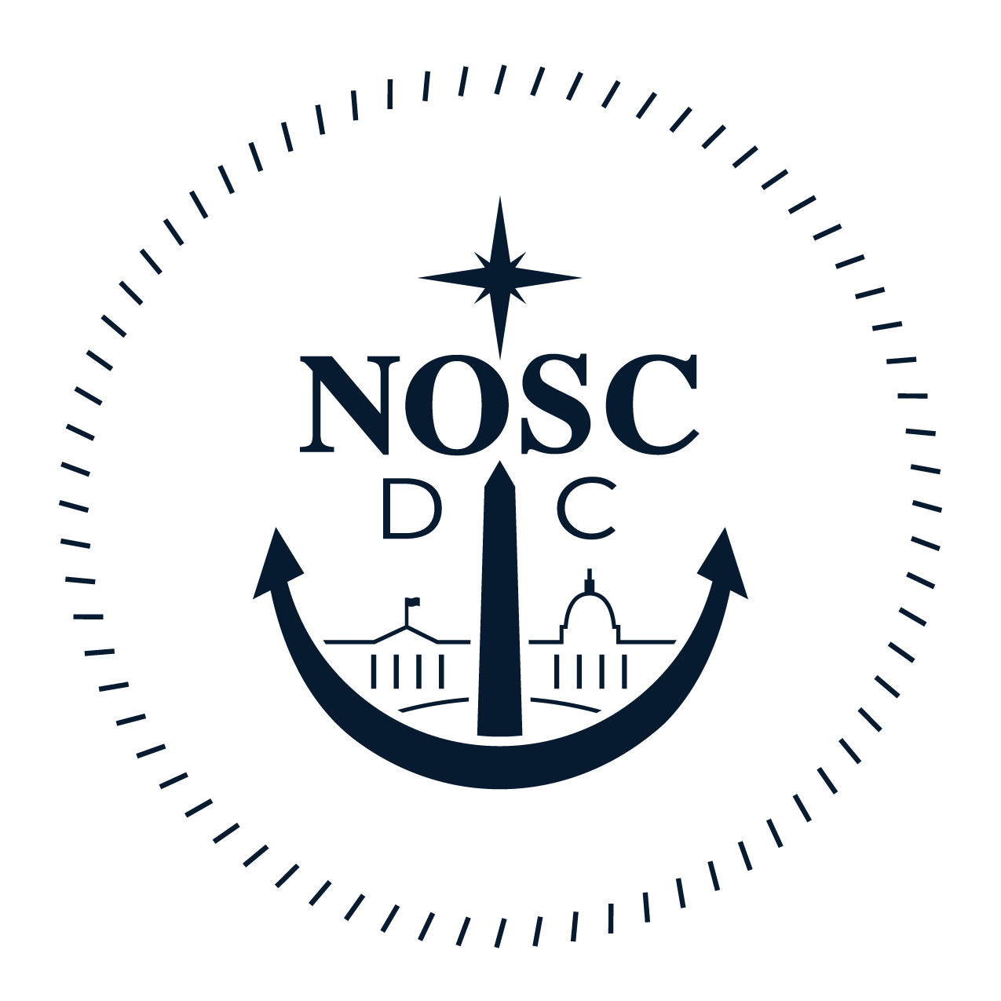 | NAVAL OFFICERS’ SPOUSES’ CLUB OF WASHINGTON, DC  2017 SCHOLARSHIP APPLICATION FORM – MILITARY SPOUSE  APPLICATIONS MUST BE POSTMARKED BY APRIL 1, 2017

ELIGIBILITY:
- Applicant must be the spouse of an Active Duty (AD) United States Navy (USN) service member who currently serves within the Naval District Washington (NDW) (defined as “the District of Columbia; the Maryland counties of Anne Arundel, Calvert, Charles, Frederick, Montgomery, Prince George's, and St. Mary's; the Virginia counties of Loudoun, Fauquier, Fairfax, Prince William, Stafford, King George, Westmoreland, Arlington, and the cities within their outer boundaries”) and who has been on AD for at least nine consecutive months.
- Applicant must reside within the boundaries of NDW area at the time of application.
- Applicant must currently be attending or applying to attend an accredited institution, such as a two- or four- year undergraduate college, a visual or performing arts school, or a vocational/technical school. If awarded a scholarship, the student must use the monies provided during the 2017-2018 academic year. If applicant receives a full scholarship or tuition and fees are covered by the GI Bill with the Yellow Ribbon Program, the applicant is no longer eligible.
- Previous NOSC Washington scholarship recipients may not reapply. However, those who have previously applied, but DID NOT RECEIVE a scholarship, are eligible to reapply.
AWARDS:
- Scholarships are awarded on the basis of the spouse’s academic record, job record, volunteer work, participation in community-based activities, and a brief essay. Financial need is not considered.
- The club treasurer will pay awards only directly to the accredited institution the scholarship recipient will be attending. Awards will only be paid after receipt of attendance verification from the college or university.
- Awards can only be used towards tuition or fees. Awards may not be used for room, board, books, or personal expenses.
- Awards will be paid in a single installment.

INSTRUCTIONS:
- The entries on this application form must be complete, accurate, and legible.
- As used in this application, the term “sponsor” refers to the spouse through whose military service eligibility is claimed.
- Ensure that the information you enter about your sponsor accurately describes his or her current status.
- Fill in all the information requested. If the answer is “none” or “not applicable,” please explain. Review the form for completeness and all answers for correctness. Use this year’s current form. Do not send resumes or copies of awards. Provide only the information requested. Sign the application form and ensure that your sponsor also signs it. (If your sponsor is unable to sign the application, please state why he/she is unable to sign and who is signing in your sponsor’s place). APPLICANTS WILL BE INELIGIBLE FOR CONSIDERATION IF ANY SIGNATURES ARE MISSING!

- Continued on Page 2
- **There are seven (7) items required for application consideration**

1. _____ | Completed Application (PART I-IV)
2. _____ | Official SAT/ACT/GRE Scores
3. _____ | Essay (PART V)
4. _____ | Copy of Current College and/or High School Transcripts
5. _____ | Letter of Recommendation from Teacher, Counselor, Principal, Volunteer Coordinator or Employer (PART VI)
6. _____ | Signed Privacy Statement (signed by applicant and sponsor)
7. _____ | Signed Publicity Statement (signed by applicant)

For any questions, please contact NOSC Scholarship Chairman, Mary K Page, at scholarship@noscdc.com .

Mail to: Naval Officers' Spouses' Club of Washington DC Scholarship Committee
6403 Chatham Park Drive
Brandywine, MD 20613

PART I: APPLICANT INFORMATION
1. Applicant’s name: ___________________________________________________________
2. Address: __________________________________________________________________
City: __________________________ State: ______________ Zip: ________________
3. Email-address: _____________________________________________________________
4. Home Phone Number: (____)_____________ Cell Phone Number: (____)_______________
5. Gender (Circle one): F M
6. Year of high school graduation or receipt of high school equivalent: ____________________
7. Previous colleges, universities, or vocational schools you have attended:
____________________________________________________________________________
____________________________________________________________________________
____________________________________________________________________________
8. Educational institutions you are currently attending or to which you have been accepted:
____________________________________________________________________________
____________________________________________________________________________
9. What is the field of study of your degree? ________________________________________

PART II: SPONSOR INFORMATION:
1. Name of sponsor through whose military service qualification is claimed: ________________
2. Home Address of Sponsor: ____________________________________________________
City: ________________________________ State: ______________ Zip: __________
3. Current Rate/Rank Held: _____________________________________________________
4. Name of Current Duty Station: _________________________________________________
5. Address of Duty Station: ______________________________________________________
6. Work Phone Number: (______)_________________________________________________

PART III: COMMUNITY INVOLVEMENT
Please describe your community involvement within the past five years in the order of importance to you. Include specific events and/or major accomplishments or awards.

Dates of Participation Community Involvement Activity
/ Total Hours including leadership positions held & honors awarded
__________________ ________________________________________________________
__________________ ________________________________________________________
__________________ ________________________________________________________
__________________ ________________________________________________________
__________________ ________________________________________________________
__________________ ________________________________________________________
__________________ ________________________________________________________
__________________ ________________________________________________________
Total Volunteer Hours over the last year_________________________________________

PART IV: WORK EXPERIENCE (Both paid and volunteer positions not included above)

Specific nature of work Employer Approximate dates Total Hours

__________________________ _____________________ _______________ __________
__________________________ _____________________ _______________ __________
__________________________ _____________________ _______________ __________
__________________________ _____________________ _______________ __________
__________________________ _____________________ _______________ __________

Total Work Hours over the last year_________________________________________

PART V: ESSAY

We would like to know more about you, specifically what makes you uniquely qualified for this
Scholarship.

- How would you describe yourself, your weaknesses, your strengths, and your challenges?
- How have your experiences as a military spouse shaped your life?

On a separate piece of paper, please write an essay that is no more than 600 words that addresses all of the above questions.

PART VI: LETTER OF RECOMMENDATION
Include a one-page letter of recommendation from one of your employers, high school teachers, counselors, principals, or volunteer coordinators who is not a relative. Letters of recommendations should include examples of academic/work and personal achievements which serve to illustrate both your character and your fitness to receive the NOSC scholarship.

NAVAL OFFICERS’ SPOUSES’ CLUB (NOSC) OF WASHINGTON, D.C.
2017 SCHOLARSHIP APPLICATION
PRIVACY STATEMENT

The purpose of the information is to apply for educational financial assistance. Information provided will be used to assess scholastic achievement. Completion of the form is mandatory. Failure to provide required information may result in disqualification from participation in the scholarship program. All application information and documentation must be postmarked no later than April 1, 2017. Incomplete application packets or applications postmarked after the deadline are ineligible for consideration.
I certify that this application and all supporting documents, to the best of my knowledge, are complete and accurate and that I possess a valid military dependent identification card. Upon request, I will make that identification card available for review by the NOSC of Washington, D.C.
I further understand that the information in this application is exclusively for the use of the NOSC of Washington D.C. Scholarship Selection Committee and will not be shared with other individuals or agencies without my consent.
I also agree that, if I am selected as a recipient, any and all information submitted with this application (including photos when submitted at a later date) may be used for purposes of news and publicity by the NOSC of Washington, D.C. Scholarship Program and all current and future promotions of this program.

Applicant’s Name Printed Applicant’s Signature Date

__________________________ _________________________ ________

Sponsor’s Signature Date
(Or other verifying signature if sponsor is unable to sign. Please provide explanation.)

__________________________ _______

NAVAL OFFICERS’ SPOUSES’ CLUB (NOSC) OF WASHINGTON, D.C.
2017 MILITARY SPOUSE SCHOLARSHIP APPLICATION
PUBLICITY STATEMENT

I do I do not

give the NOSC of Washington, D.C. permission to use my name, any image of myself, and biographical information provided by me for purpose of publicity in media outlets, including print, news, magazines, radio, TV, online, scrapbooks, and onto the NOSC of Washington, D.C. web page.

Applicant’s Name Printed Applicant’s Signature Date

__________________________ _________________________ ________

